

RAJALAKSHMI INSTITUTE OF TECHNOLOGY
(An Autonomous Institution, Affiliated to Anna University, Chennai)

DEPARTMENT OF ARTIFICIAL INTELLIGENCE AND DATA SCIENCE ACADEMIC YEAR 2025 - 2026
SEMESTER III

ARTIFICIAL INTELLIGENCE LABORATORY MINI PROJECT REPORT

REGISTER NUMBER | 2117240070152
NAME | KEERTHI VASAN S
PROJECT TITLE | Guess The Number Using Binary Search AI
DATE OF SUBMISSION
FACULTY IN-CHARGE | Mrs. PHEBE PERSIS

Signature of Faculty In-Charge:

C˛* PROJECT TITLE:
Guess the Number Game using Binary Search AI

H_] INTRODUCTION:
Artificial Intelligence can be applied to decision-making and search problems using efficient algorithms. Binary Search is a classic AI strategy for narrowing down possibilities in a sorted
space. This project implements a number guessing game where the AI uses binary search logic to guess a number chosen by the user. It demonstrates how AI can simulate intelligent behavior through systematic elimination and feedback-driven learning.

Ç PROBLEM STATEMENT:
Design an AI system that can guess a number between a given range using binary search. The user thinks of a number, and the AI tries to guess it in the minimum number of steps by asking whether the number is higher, lower, or equal.

●◎’" ´ GOAL:
- Implement a binary search-based guessing algorithm.
- Minimize the number of guesses required.
- Simulate intelligent decision-making using feedback loops.

–'–‘ l_H µ_µ THEORETICAL BACKGROUND:
- Binary Search: A divide-and-conquer algorithm that halves the search space at each step.
- AI Decision Logic: Uses feedback to adjust search boundaries.
- Literature Survey: Binary search is widely used in AI for search optimization, decision trees, and game logic.

- Justification: Binary search guarantees logarithmic time complexity, making it ideal for efficient guessing.

⚙ ALGORITHM EXPLANATION WITH EXAMPLE:
Step 1: Set initial range (e.g., 1 to 100). Step 2: AI guesses the midpoint.
Step 3: User responds with “higher”, “lower”, or “correct”. Step 4: AI adjusts range and repeats until correct guess.
Example:
User thinks of 73 → AI guesses 50 → “higher” → guesses 75 → “lower” → guesses 62 → “higher” → … → guesses 73 → “correct”

□_ □¿ IMPLEMENTATION AND CODE:
import time

def guess_number():
print("●◎’" ´ Think of a number between 1 and 100.") print("'’˘⬛*_' The AI will try to guess it!")
input("Press Enter when ready...")

low = 1
high = 100
attempts = 0

while low <= high: attempts += 1
guess = (low + high) // 2 print(f"\nAI guesses: {guess}") time.sleep(1)

feedback = input("Is it (H)igh, (L)ow, or (C)orrect? ").lower()

if feedback == 'c':
print(f"\n⬛ Yay! The AI guessed your number {guess} correctly in {attempts} attempts!") break
elif feedback == 'h': high = guess - 1
elif feedback == 'l': low = guess + 1
else:
print("+ Invalid input! Please enter H, L, or C.")

if low > high:
print("\n● • ^ ˙ Seems there was a mistake. Try again!")

# Run the game
if _name_ == "_main_": guess_number()

OUTPUT:
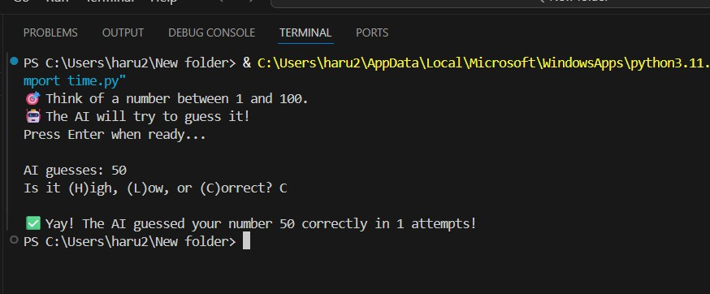

Step-by-Step Explanation:
- Starting the Game:
The program asks you to think of a number between 1 and 100. You don’t tell it — the AI will guess using logic.
- AI’s First Guess:
AI guesses: 50
The AI starts at the middle of the range (1–100). You must respond:
H → if your number is lower than 50 L → if your number is higher than 50 C → if 50 is correct

- Your Response (Example):
You type l (means your number is higher than 50).
→ Now the AI knows your number is between 51 and 100.
- Next Guess:
AI guesses: 75
The AI again picks the middle of the new range (51–100). You type h (means your number is lower than 75).
→ Now the new range becomes 51–74.
- Next Guess:
AI guesses: 62
The AI picks the middle of 51–74. You type c (means correct).
- Final Output:
⬛ Yay! The AI guessed your number 62 correctly in 3 attempts!
The AI stops guessing and shows the total attempts

#/¡ ç RESULTS AND FUTURE ENHANCEMENT:
- The AI successfully guessed the number using binary search.
- Compared to random guessing, binary search is faster and more efficient.
- Future enhancements:
  - Add GUI for interactive play.
  - Extend to multi-player or timed challenges.
  - Use reinforcement learning to adapt guessing strategy based on user behavior.

³ GITHUB LINK OF THE PROJECT AND REPORT:

https://github.com/harinip28/AI.git

_ H_l ‘–'µ–µ REFERENCES:
- Cormen, T. H. – Introduction to Algorithms
- Python Official Documentation – https://docs.python.org
- “Binary Search Explained” – GeeksforGeeks
- “AI Game Logic” – Towards Data Science
- MIT OpenCourseWare – Algorithmic Thinking

